Springfield Library

Manager’s Report
January 2023

Presented to the Board of Directors by Hanna Conbeer, Library Manager

Community Collaborations
I connected with Elizabeth Stutzman, the schoolteacher for the Amish school. She borrowed the first round of elementary school supplies and books for use in their classroom. We have set up a routine drop-off/pick up of materials on the third Wednesday of each month. I promoted our services to the general Amish community through this connection and have seen 6 Amish visit the library this past month. I am hopeful that this will continue to grow our outreach.
I am continuing to collaborate with Colin Havener from Hyde Hall to provide a virtual storytime. Videos are available on Youtube under Hyde Hall NY. Their username on Youtube is: @hydehallcooperstownny1566.

Four County Library System Meetings
Directors Meeting January 12, 2022: Directors discussed the NYS Annual Report, trustee training workshops, advocacy day, notes from the field including Sidney looking for a new director, BCPL getting a new website and new assistant director, paying staff for organizing bookclubs, 4CLS will be contacting emergency services so that they can contact libraries in event of emergency.

Fundraising and Grants
Submitted:
- Stewart's Holiday Match - Submitted for $2,000 for Summer Reading program.
- Community Foundation of South Central New York Small Grants: Submitted for $2,000 for Adult Education Programming June-August.

Statistics

E-Book Circulation
Month | 2021 |  | 2022 |  |  | 2023
 | Ebooks | Audiobooks | Ebooks | Audiobooks | Magazines | Ebooks | Audiobooks | Magazines
January | 6 | 4 | 14 | 12 |  | 10 | 9
February | 9 | 6 | 7 | 18
March | 4 | 8 | 10 | 8
April | 5 | 6 | 6 | 10
May | 7 | 8 | 4 | 3
June | 13 | 4 | 11 | 2
July | 13 | 3 | 13 | 11
August | 3 | 1 | 5 | 11
September | 5 | 0 | 11 | 11 | 1
October | 10 | 0 | 8 | 18 | 1
November | 16 | 11 | 14 | 12 | 3
December | 13 | 11 | 1 | 11

Visitors, Circulation, Reference Questions, Hours
 | Visitors |  |  | Circulation |  |  | Reference Questions |  |  | Hours Open
Month | 2021 | 2022 | 2023 | 2021 | 2022 | 2023 | 2021 | 2022 | 2023 | 2021  Open | 2021  Closed | 2022 Open | 2022  Closed | 2023 Open | 2023 Closed
January | 24 | 209 | 192 | 169 | 440 | 481 | 5 | 35 | 33 | 14 |  | 83 | 3- Holiday | 82
February | 46 | 277 |  | 354 | 645 | 517 | 9 | 37 |  | 16 |  | 81
March | 42 | 287 |  | 439 | 585 |  | 7 | 66 |  | 16 |  | 100
April | 52 | 197 |  | 500 | 379 |  | 3 | 52 |  | 18 |  | 83
May | 88 | 207 |  | 270 | 501 |  | 8 | 24 |  | 18 |  | 82
June | 188 | 250 |  | 297 | 512 |  | 34 | 52 |  | 96 |  | 95
July | 203 | 313 |  | 359 | 560 |  | 61 | 65 |  | 93 |  | 83
August | 134 | 301 |  | 402 | 645 |  | 27 | 42 |  | 82 |  | 92
September | 171 | 215 |  | 522 | 511 |  | 18 | 31 |  | 95 |  | 88
October | 195 | 274 |  | 535 | 532 |  | 14 | 23 |  | 83 |  | 84
November | 142 | 204 |  | 512 | 566 |  | 27 | 25 |  | 68 | 14 – Holiday | 83 | 7 - Holiday
December | 219 | 265 |  | 496 | 534 |  | 20 | 26 |  | 92 | 3- Holiday | 84 | 6 - Holidays

New Library Card Registrations, Volunteers, Book Purchases, Grant Expenditures
 | New library cards registered: | Volunteers and Hours: | Amount Purchased from Book Fund: | Book Fund Remaining: | Grant Money Spent:
January | 4 | 3 Volunteers  6 Hours | $127.38 | $1,372.62 | $43.41 – Community Foundation of Otsego County COVID Relief Fund
New Books from Donations:
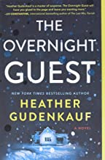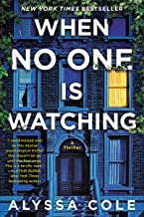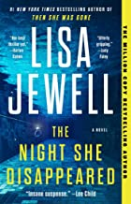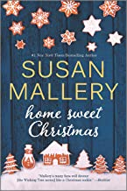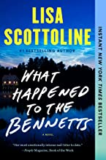
New Books Purchased with Book Funds:
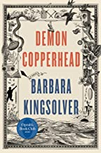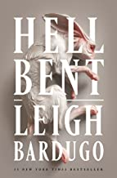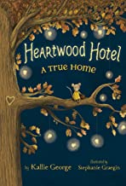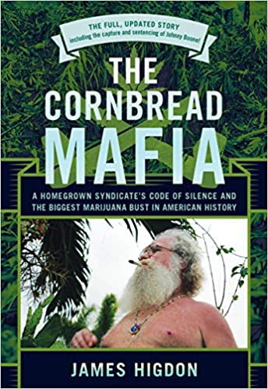
“Cornbread Mafia” and “Deep Nutrition” were purchased as a result of two different patron requests.

Programming
 | Program | Type of Program | Attendance Adults | Attendance Children 0-5 | Attendance Children 6-11 | Attendance Youth 12-18
Tuesday, January 3 | Kids Create Club | Child All Ages | 2 | 3 | 3
Wednesday, January 4 | Storytime | Child 0-5 | 3 | 3 | 2
Thursday, January 5 | Art Club | Adult | 3
Saturday, January 7 | Lego Club | Child All Ages | 0
Tuesday, January 10 | Writers Group | Adult | 2
Wednesday, January 11 | Storytime | Child 0-5 | 2 | 6
Saturday, January 14 | Puzzle Swap | Adult | 5
Wednesday, January 18 | Springfield Reads/Storytime | Child 0-5 | 1 | 3 | 2
Thursday, January 19 | Art Club | Adult | 0
Friday, January 20 | Book Club | Adult | 10
Tuesday, January 24 | Money for Kids Club | Child All Ages | 1 |  | 2
Wednesday, January 25 | Homeschool Storytime | Child All Ages | 6 | 6 | 13
Tuesday, January 31 | Kids Create Club | Child All Ages | 2 |  | 3
January Totals | 14 Programs | 3 Child 0-5  6 Child All Ages  5 Adult | 37 Adults Attended | 21 Children 0-5 attended | 25 Children 6-11 attended | 0 Youth 12-18 attended

