The convenience fee is applied to reduce the costs associated with accepting online credit card payments.

Refunds may be issued at the discretion of the local library. Contact them directly for their policy.

**Pay Your Library Fines Online!**

C:\Users\sbachman.4CLS\AppData\Local\Microsoft\Windows\Temporary Internet Files\Content.IE5\L8RMF8UM\MC900030049[1].wmf

Your local libraries are now using a system that allows patrons to pay their library fines online with a credit card.

It is secure, fast, and easy. Payments can be made online 24 hours a day, 7 days a week.

Read more inside!

At this point, credit transactions can only be processed online. Fines cannot be paid by credit card in person at the library.

-A $1.00 convenience fee is applied to each transaction

-Accepted cards include: Visa, Mastercard, American Express, & Discover

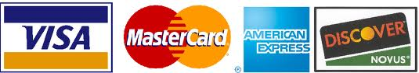

-Only credit transactions can be executed (not debit)

-No credit card information is stored on library computers.

-No user information is passed onto the payment processor

-ProPay, our payment processor, is fully PCI compliant for your security

-Transactions are immediately registered on your user account

How It Works:

* Go to the online catalog
  + [www.4cls.org](http://www.4cls.org)
* Click on My Account
  + Log in with your library card number and PIN*
* Click on the Fines tab to view your fines
* Check the box next to the fine(s) you wish to pay, then click on Pay Fines
* Enter your credit card information and click Submit
  + Check the box & enter an e-mail address to receive a receipt via e-mail
* Print the payment confirmation for your records (if desired)

*If you do not know your PIN, contact your local library.